SQL:

This work focuses on analyzing organizational data to generate meaningful insights about employees, departments, and company-wide trends. Using SQL queries across core tables such as EMPLOYEES, DEPARTMENTS, JOBROLES, SALARIES, PERFORMANCE_REVIEWS, and LOCATIONS1, the analysis highlights key aspects of workforce management and decision-making.

Database

USE COMPANY_DB3;

Tables

DEPARTMENT
Departments define the organizational structure by grouping employees into functional units. Each department is identified by a unique ID and name, allowing HR teams to evaluate performance, attrition, and stability at the unit level. This table is crucial for comparing workforce metrics across different business areas and identifying which departments are thriving or struggling.

CREATE TABLE DEPARTMENTS(DEPID INT PRIMARY KEY,DNAME VARCHAR(35) NOT NULL UNIQUE);

LOCATIONS1
The locations table records the geographical distribution of employees, linking each individual to a specific office or region. This information is valuable for location‑wise salary comparisons, diversity analysis, and understanding workforce distribution. It helps organizations assess whether compensation and representation are balanced across different regions.

CREATE TABLE LOCATIONS1(LID INT PRIMARY KEY,LNAME VARCHAR(35) NOT NULL);

JOBROLES
The job roles table outlines the positions available within the company. Each role is linked to employees through a role ID, making it possible to track career progression and promotions. By analyzing job roles, HR can understand salary structures, identify employees who have advanced through multiple roles, and evaluate readiness for leadership positions.

CREATE TABLE JOBROLES(RID INT PRIMARY KEY,RNAME VARCHAR(35) NOT NULL,MIN_SALARY DECIMAL(10,2),MAX_SALARY DECIMAL(10,2));

EMPLOYEES
The employees table serves as the central hub of the database, containing essential information about each individual in the organization. It typically includes identifiers such as employee ID and name, along with references to their department, job role, and location. Additional attributes like join date, employment status, and gender (if tracked) provide context for tenure, diversity, and workforce stability.

CREATE TABLE EMPLOYEES(EMPID INT PRIMARY KEY,ENAME VARCHAR(35) NOT NULL,GENDER VARCHAR(11),DEPID INT,RID INT,LID INT,JOINDATE DATE,STATUS VARCHAR(35) DEFAULT 'ACTIVE',FOREIGN KEY(DEPID) REFERENCES DEPARTMENTS(DEPID),FOREIGN KEY(RID) REFERENCES JOBROLES(RID),FOREIGN KEY(LID) REFERENCES LOCATIONS1(LID));

SALARIES
Salary data is stored in this table, linked to employees by their ID. It provides the basis for compensation analysis, enabling comparisons across departments, roles, and locations. Salary information also supports advanced analytics such as correlation studies between pay and performance, and helps identify cases where compensation may not align with contribution.

CREATE TABLE SALARIES(SALID INT PRIMARY KEY,EMPID INT,SALARY DECIMAL(10,2),EFFECTIVE_DATE DATE,FOREIGN KEY(EMPID) REFERENCES EMPLOYEES(EMPID));

PERFORMANCE_REVIEWS
Performance reviews capture employee ratings over time, usually by year. This table is essential for monitoring trends, evaluating promotion eligibility, and identifying high performers who may be suitable for leadership roles. It also enables department‑level performance comparisons and supports correlation analysis with salary data.

CREATE TABLE PERFORMANCE_REVIEWS(REVIEWID INT PRIMARY KEY,EMPID INT,REVIEW_YEAR INT,RATING DECIMAL(2,1) CHECK (RATING BETWEEN 1 AND 5),FOREIGN KEY(EMPID) REFERENCES EMPLOYEES(EMPID));

INSERTING VALUES TO TABLES DIV
BULK INSERT DEPARTMENTS
FROM 'C:\Dataset\Departments Dataset - Sheet1.csv'
WITH (
FIRSTROW = 2,
FIELDTERMINATOR = ',',
ROWTERMINATOR = '\n',
TABLOCK
);

BULK INSERT LOCATIONS1
FROM 'C:\Dataset\Locatioin_dataset - Sheet1.csv'
WITH (
FIRSTROW = 2,
FIELDTERMINATOR = ',',
ROWTERMINATOR = '\n',
TABLOCK
);

BULK INSERT JOBROLES
FROM 'C:\Dataset\Job_roles_dataset - Sheet1.csv'
WITH (
FIRSTROW = 2,
FIELDTERMINATOR = ',',
ROWTERMINATOR = '\n',
TABLOCK
);

BULK INSERT EMPLOYEES
FROM 'C:\Dataset\Employees_100_Records - Employees_100_Records.csv'
WITH (
FIRSTROW = 2,
FIELDTERMINATOR = ',',
ROWTERMINATOR = '\n',
TABLOCK
);

BULK INSERT SALARIES
FROM 'C:\Dataset\Salaries_Data - Salaries_Data.csv'
WITH (
FIRSTROW = 2,
FIELDTERMINATOR = ',',
ROWTERMINATOR = '\n',
TABLOCK
);

BULK INSERT PERFORMANCE_REVIEWS
FROM 'C:\Dataset\performance.xlsx - Sheet1.csv'
WITH (
FIRSTROW = 2,
FIELDTERMINATOR = ',',
ROWTERMINATOR = '\n',
TABLOCK
);

PERFORMANCE ANALYSIS
1.TOP10 PERFORMANCE OF EMPLOYEES .
SELECT TOP 10 EMPLOYEES.* FROM PERFORMANCE_REVIEWS inner join EMPLOYEES ON PERFORMANCE_REVIEWS.EMPID=EMPLOYEES.EMPID ORDER BY PERFORMANCE_REVIEWS.RATING DESC;
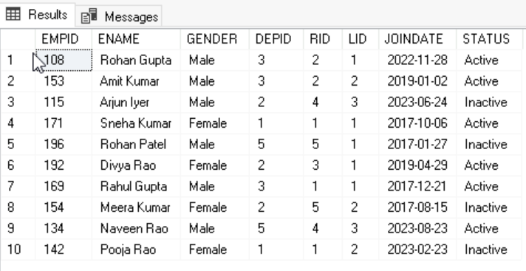
2.Average rating per department
SELECT D.DNAME AS Department, AVG(P.RATING) AS AvgRating FROM EMPLOYEES E
JOIN DEPARTMENTS D ON E.DEPID = D.DEPID JOIN PERFORMANCE_REVIEWS P
ON E.EMPID = P.EMPID GROUP BY D.DNAME ORDER BY AvgRating DESC;
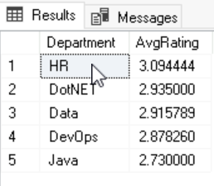
3.Employees eligible foR promotion (rating>4 & 2+ years)
SELECT E.EMPID, E.ENAME, D.DNAME AS Department, J.RNAME AS JobRole, P.RATING, E.JOINDATE, DATEDIFF(YEAR, E.JOINDATE, GETDATE()) AS YearsInCompany
FROM EMPLOYEES E JOIN DEPARTMENTS D ON E.DEPID = D.DEPID
JOIN JOBROLES J ON E.RID = J.RID
JOIN PERFORMANCE_REVIEWS P ON E.EMPID = P.EMPID WHERE P.RATING > 4 AND DATEDIFF(YEAR, E.JOINDATE, GETDATE()) >= 2 ORDER BY P.RATING DESC, YearsInCompany DESC;
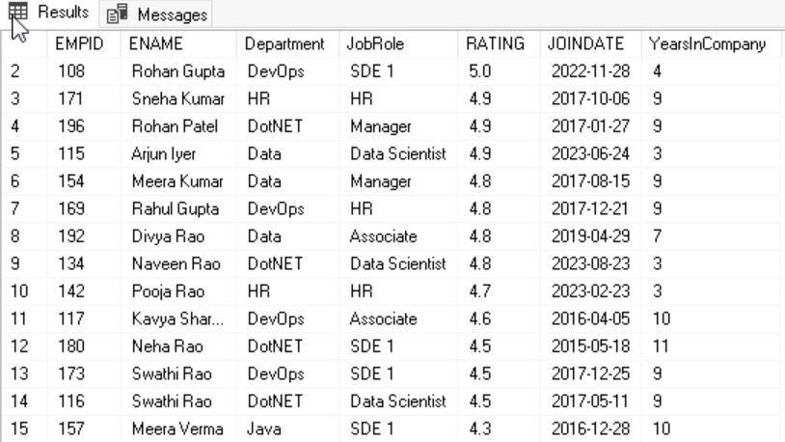
4.PERFORMANCE TREND OVER YEARS
SELECT REVIEW_YEAR, AVG(RATING) AS AvgPerformanceRating, COUNT(*) AS TotalReviews FROM PERFORMANCE_REVIEWS GROUP BY REVIEW_YEAR ORDER BY REVIEW_YEAR;

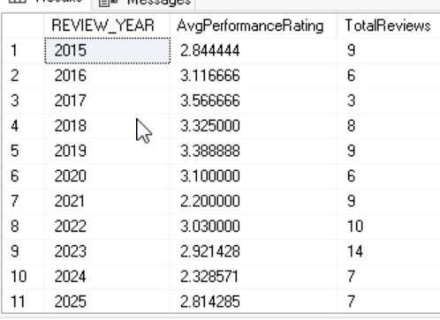
SALARY ANALYTICS
5.SALARY DISTRIBUTION PER DEPARTMENT
SELECT E.DEPID,SUM(S.SALARY) FROM SALARIES S INNER JOIN
EMPLOYEES E ON S.EMPID=E.EMPID GROUP BY E.DEPID;
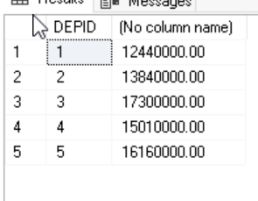
6.HIGHEST AND LOWEST SALARY PER ROLE
SELECT E.RID,MIN(S.SALARY),MAX(S.SALARY) FROM JOBROLES J
INNER JOIN EMPLOYEES E ON J.RID=E.RID INNER JOIN SALARIES S ON E.EMPID=S.EMPID GROUP BY E.RID;
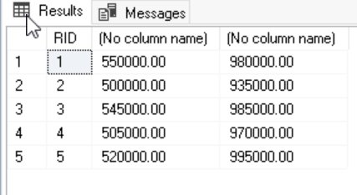
7.SALARY VS PERFORMANCE CORELATION
SELECT SUM((S.SALARY - AvgSalary) * (P.RATING - AvgRating)) / SQRT(SUM(POWER(S.SALARY - AvgSalary, 2)) * SUM(POWER(P.RATING - AvgRating, 2))) AS CorrelationCoefficient FROM ( SELECT S.SALARY, P.RATING, AVG(S.SALARY) OVER() AS AvgSalary, AVG(P.RATING) OVER() AS AvgRating FROM SALARIES S
JOIN PERFORMANCE_REVIEWS P ON S.EMPID = P.EMPID ) AS Sub;

8.EMPLOYEES BELOW DEPARTMENT AVERAGE
SELECT E.EMPID, E.ENAME, D.DNAME AS Department, S.SALARY FROM EMPLOYEES E
JOIN DEPARTMENTS D ON E.DEPID = D.DEPID
JOIN SALARIES S ON E.EMPID = S.EMPID WHERE S.SALARY < ( SELECT AVG(S2.SALARY) FROM EMPLOYEES E2
JOIN SALARIES S2 ON E2.EMPID = S2.EMPID WHERE E2.DEPID = E.DEPID );
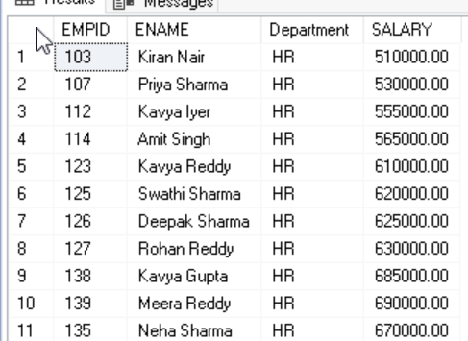
DEPARTMENT GROWTH
9.HIRING TREND PER YEAR
SELECT YEAR(JOINDATE) AS HireYear, COUNT(*) AS TotalHires FROM EMPLOYEES GROUP BY YEAR(JOINDATE) ORDER BY HireYear;
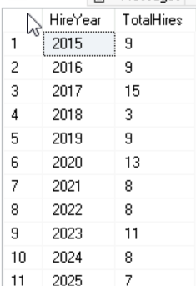
10.HEAD COUNT GROWTH BY DEPARTMENTS
SELECT D.DNAME AS Department, YEAR(E.JOINDATE) AS YearJoined, COUNT(E.EMPID) AS Headcount FROM EMPLOYEES E
JOIN DEPARTMENTS D ON E.DEPID = D.DEPID GROUP BY D.DNAME, YEAR(E.JOINDATE) ORDER BY D.DNAME, YearJoined;
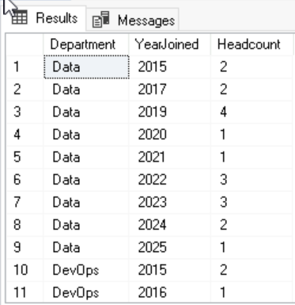
STRATEGIC INSIGHTS
12.EMPLOYEES OVER DUE FOR PROMOTION
SELECT E.EMPID, E.ENAME, D.DNAME AS Department, J.RNAME AS JobRole, E.JOINDATE, DATEDIFF(YEAR, E.JOINDATE, GETDATE()) AS YearsInCompany FROM EMPLOYEES E
JOIN DEPARTMENTS D ON E.DEPID = D.DEPID JOIN JOBROLES J ON E.RID = J.RID WHERE DATEDIFF(YEAR, E.JOINDATE, GETDATE()) >= 3;
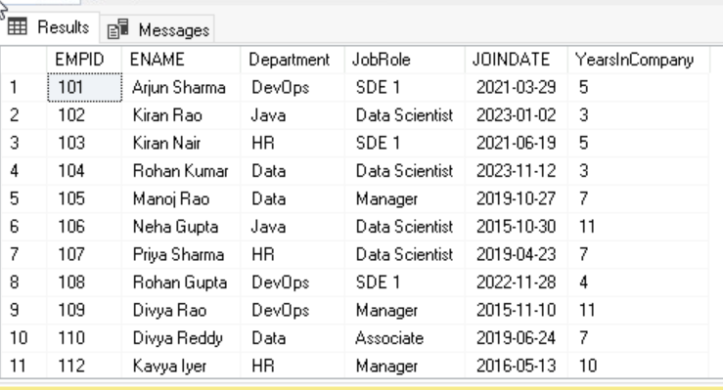
13.HIGH SALARY BUT LOW PERFORMANCES CASES
SELECT E.EMPID, E.ENAME, D.DNAME AS Department, J.RNAME AS JobRole, S.SALARY, P.RATING FROM EMPLOYEES E
JOIN DEPARTMENTS D ON E.DEPID = D.DEPID
JOIN JOBROLES J ON E.RID = J.RID
JOIN SALARIES S ON E.EMPID = S.EMPID
JOIN PERFORMANCE_REVIEWS P ON E.EMPID = P.EMPID WHERE S.SALARY > (SELECT AVG(SALARY) FROM SALARIES) AND P.RATING < 3 ORDER BY S.SALARY DESC, P.RATING ASC;
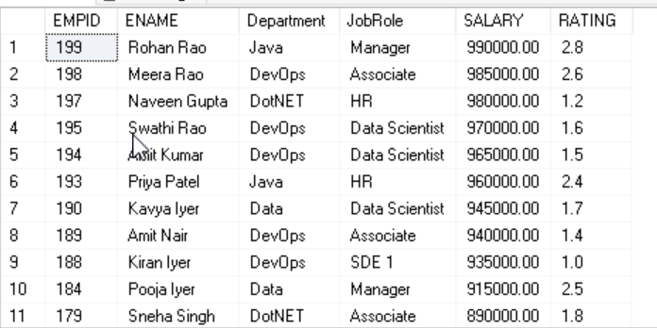
16.LOCATION-WISE SALARY COMPARISION
SELECT L.LNAME AS Location, AVG(S.SALARY) AS AvgSalary, MIN(S.SALARY) AS MinSalary, MAX(S.SALARY) AS MaxSalary, COUNT(E.EMPID) AS EmployeeCount FROM EMPLOYEES E
JOIN LOCATIONS1 L ON E.LID = L.LID JOIN SALARIES S ON E.EMPID = S.EMPID GROUP BY L.LNAME ORDER BY AvgSalary DESC;
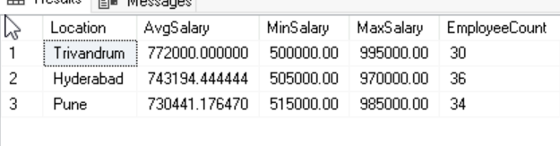
17.GENDER DIVERSITY RATIO(IF ADDED)
SELECT D.DNAME AS Department, SUM(CASE WHEN E.GENDER = 'Male' THEN 1 ELSE 0 END) AS MaleCount, SUM(CASE WHEN E.GENDER = 'Female' THEN 1 ELSE 0 END) AS FemaleCount, COUNT(E.EMPID) AS TotalEmployees, CAST(SUM(CASE WHEN E.GENDER = 'Female' THEN 1 ELSE 0 END) AS FLOAT) / NULLIF(COUNT(E.EMPID),0) AS FemaleRatio, CAST(SUM(CASE WHEN E.GENDER = 'Male' THEN 1 ELSE 0 END) AS FLOAT) / NULLIF(COUNT(E.EMPID),0) AS MaleRatio FROM EMPLOYEES E JOIN DEPARTMENTS D ON E.DEPID = D.DEPID GROUP BY D.DNAME ORDER BY FemaleRatio DESC;
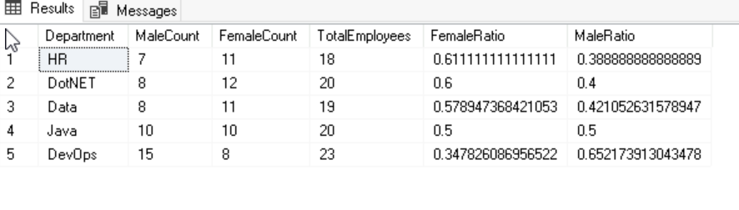
18.MEDIAN SALARY CALCULATIONS
SELECT * FROM(SELECT SALARIES.*,ROW_NUMBER()OVER(ORDER BY SALARY ASC)AS R FROM SALARIES)AS SALNEW1 WHERE R=(SELECT ROUND(COUNT(*)/2,0)
FROM SALARIES);
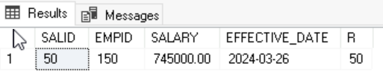
19.EMPLOYEES WITH MULTIPLE PROMOTIONS
SELECT E.EMPID, E.ENAME, COUNT(DISTINCT E.RID) AS rchanges FROM EMPLOYEES E
JOIN JOBROLES J ON E.RID = J.RID GROUP BY E.EMPID, E.ENAME HAVING COUNT(DISTINCT E.RID) > 1 ORDER BY rchanges DESC;

20.IDENTIFY LEADERSHIP PIPELINE CANDIDATES
SELECT E.EMPID, E.ENAME, D.DNAME AS Department, J.RNAME AS JobRole, P.RATING, E.JOINDATE, DATEDIFF(YEAR, E.JOINDATE, GETDATE()) AS YearsInCompany, S.SALARY FROM EMPLOYEES E JOIN DEPARTMENTS D ON E.DEPID = D.DEPID
JOIN JOBROLES J ON E.RID = J.RID JOIN SALARIES S ON E.EMPID = S.EMPID
JOIN PERFORMANCE_REVIEWS P ON E.EMPID = P.EMPID WHERE P.RATING >= 4.5 AND DATEDIFF(YEAR, E.JOINDATE, GETDATE()) >= 3 AND E.STATUS = 'ACTIVE' ORDER BY P.RATING DESC, YearsInCompany DESC, S.SALARY DESC;

